

**NAME: P.NITYASREE**

**REGNO: 17MIS1007**

**COURSE: INFORMATION SECURITY MANAGEMENT**

**COURSE CODE: CSE 3502**

**FACULTY: ANUSHA**

**WEBSITE ATTACK USING SOCIAL ENGINEERING TOOL KIT :**

**STEP 1: SELECT THE SET TOOL AS 2**

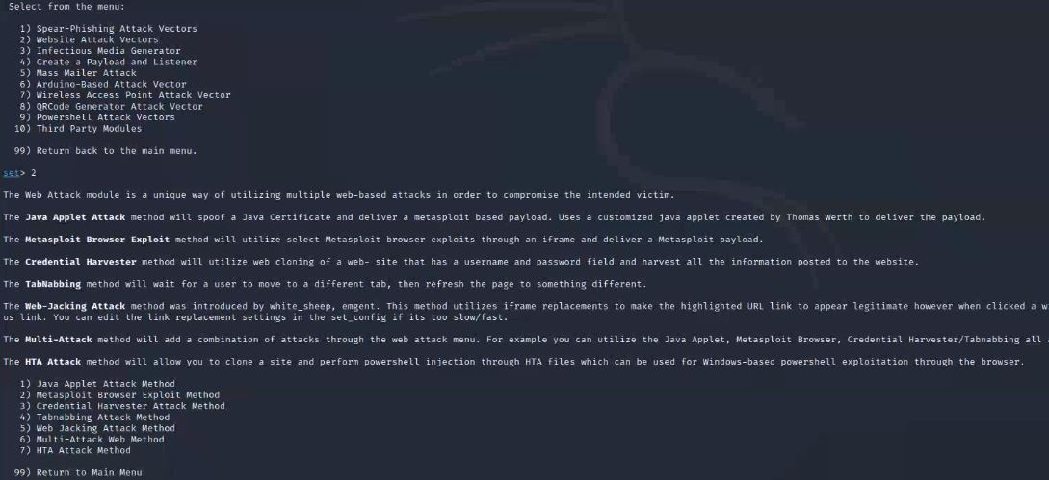

**STEP 2: SELECT HTA ATTACK METHOD**

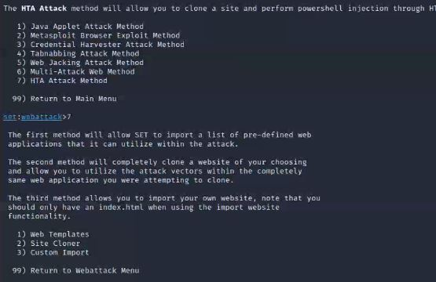

**STEP 3 : SET SUPPORTS BOTH HTTP AND HTTPS.**

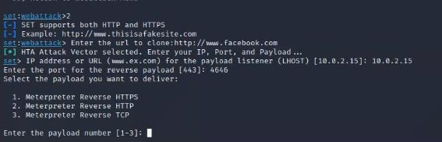

**STEP 4: ENTER THE PAYLOAD NUMBER AS METERPRETER REVERSE TCP**

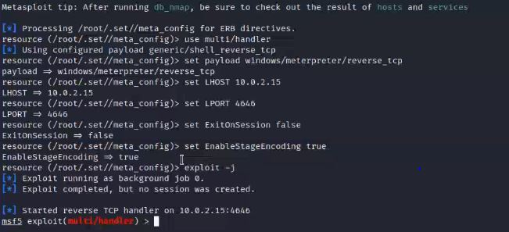

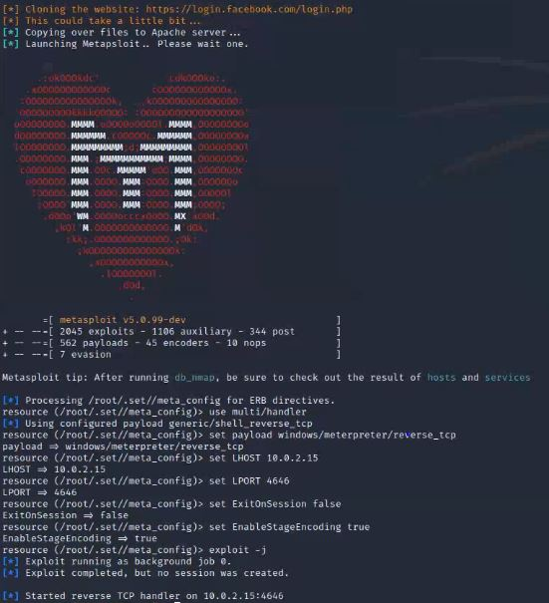

**STEP 5: AFTER DOWNLOADING FILE AND EXECUTING IT A FEW SESSIONS ARE STARTED**

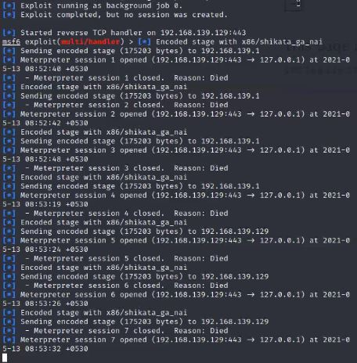

**STEP 6: AT BACKGROUND IN METASPLOIT LISTENER SHOWS ALL THE COMMANDS IN BACKGROUND**

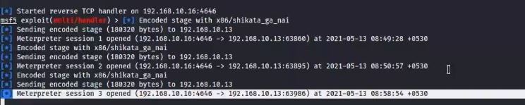

**POWER SHELL ATTACK VECTORS:**

**STEP1: SELECT POWER SHELL ATTACK VENDORS**

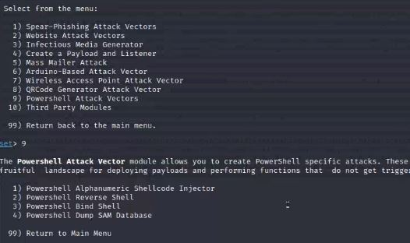

**STEP 2: SELECT POWERSHELL ALPHANUMERIC SHELLCODE INJECTOR**

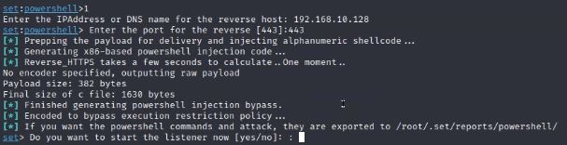

**STEP3: ENTER THE IP ADDRESS AND ALSO PORT NUMBER**

**STEP 4: AUTOMATICALLY METASPLOIT STARTED**

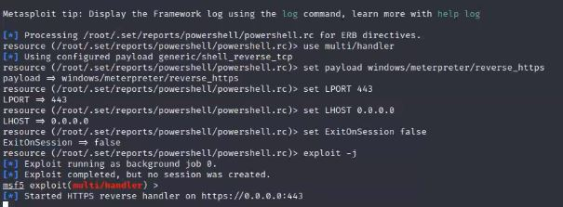

END